MARCO POLO AND KUBLAI KHAN
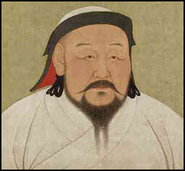
Kublai Khan After a three-and-a-half year journey, Marco Polo, his father and uncle arrived in Shangdu (Xanadu), Kublai Khan's summer capital, not so far from Beijing, in 1275, when Marco was 21. Word of the Polos journey had been relayed to Kublai Khan by Pony-Express-style messengers. Envoys of the Great Khan reached the Polos in central China. They escorted the Polos for the last 40 days of their trip to Shangdu. [Sources: Mike Edwards, National Geographic, May 2001, June 2001, July 2001 **]
Julie Makinen wrote in the Los Angeles Times, “Marco Polo arrived in the East with his father and uncle at a crucial turning point in history: The 300-year-old Song Dynasty was on the verge of collapse and Kublai was about to become the first non-Chinese emperor of China. But even as the khan was trying to take China, his own people were turning on him in a civil war, upset over what they saw as his increasing softness and excessive Sinification."Source: Julie Makinen, Los Angeles Times, September 19, 2014 ^|^]
John Fusco, screenwriter of the “Marco Polo” Netflix series told the Los Angeles Times: “Marco Polo was basically adopted as a son by Kublai Khan, the most powerful ruler on Earth, the grandson of Genghis Khan. And that he was trained in the scholar-warrior tradition — in archery, Mongol warfare, Chinese martial arts, languages, letters. He went through this incredible education that was really this cultural awakening.

Marco Polo as Kublai Khan's Envoy
Kublai Khan welcomed the Polos like long lost friends. He used Marco Polo as an emissary and ambassador in China and in other Asian kingdoms. This was not that unusual. Kublai Khan employed thousands of foreigners, mostly Persians and Arabs. Scholars deduce that Marco Polo could speak Persian and Mongol but not much Chinese (he often used Persian names rather than Chinese ones for the places he described) and spent much of his time with foreigners. Marco Polo didn't mention what his father and uncle did. It seems probable that they worked as merchants. [Sources: Mike Edwards, National Geographic, May 2001, June 2001, July 2001 **]

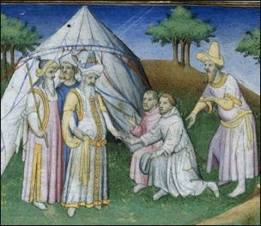
According to the Silk Road Foundation: “Marco, a gifted linguist and master of four languages, became a favorite with the khan and was appointed to high posts in his administration. He served at the Khan's court and was sent on a number of special missions in China, Burma and India. Many places which Marco saw were not seen again by Europeans until last century. Kublai Khan appointed Marco Polo as an official of the Privy Council in 1277 and for 3 years he was a tax inspector in Yanzhou, a city on the Grand Canal, northeast of Nanking. He also visited Karakorum and part of Siberia. Meanwhile his father and uncle took part in the assault on the town of Siang Yang Fou, for which they designed and constructed siege engines. He frequently visited Hangzhou, another city very near Yangzhou. At one time Hangzhou was the capital of the Song dynasty and had a beautiful lakes and many canals, like Marco's hometown, Venice. Marco fell in love with it. [Source: Silk Road Foundation silk-road.com/artl/marcopolo]
In a third person account from his book, Marco Polo wrote: "Messer Marco was in the Khan's employment some seventeen years, continually going and coming, hither and thither, on the missions that were entrusted to him...And, as he knew all the sovereign's ways, like a sensible man he always took much pains to gather knowledge of anything that would be likely to interest him, and then on his return to Court he would relate everything in regular order, and thus the Emperor came to hold him in great love and favor." **
As Kublai Khan's special envoy, Marco Polo boasted he explored "more of those strange regions than any man who was ever born." Marco Polo claimed that he was the governor of Yangzhou for three years. Some scholars think he was exaggerating. Others say he could have been telling the truth because Kublai Khan was in need of administrators. **

